Using Blender 2.6 for Animation - Topics - Replace a UVMapped Texture with Another Image

Change texture Source to an existing image (Make sure you have completed all steps to apply a UVMapped texture, then you can follow these steps):
- Double-click the blender project file
- Select the object that has the texture
- Click the Material button to select the object’s material
- Click the Texture button to edit the textures on the object’s material
- Under “Image” section, click 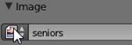 image drop-down box then make sure the same name is chosen
that was in the UV/Image Editor, circled in red in picture 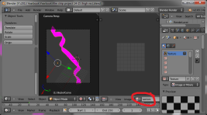 (if the view is split and the view on the right is a UV/Image Editor, your screen will look like the picture [see Using Views for Texture Paint]).
- In the “Source” section click the Browse button then choose the image

Make an image file of the 3D Scene
- Click Render, Render Image to try out the new texture.
  - If you want to save the 3D Image with a transparent background (to use as a sprite), first click “RGBA”:
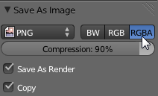
  - Then click Save As Image

TIP: If you have trouble getting the texture you chose to work on the image:
- At the top of the Texture button tab try unchecking all of the textures in the texture list so that only the UVMapped texture
- If it still doesn’t work, then in the UV/Image Editor try clicking Image, Replace, then choose the image file
- Try “Make an image file of the 3D Scene” again

TIP: If you can’t see all of the scene, make sure you move the camera object to a good place then try “Make an image file of the 3D Scene” again

