3D Animation - Topics - Engineering: Good Design vs Poor Design, Desk Example

Fiberboard and Steel Model
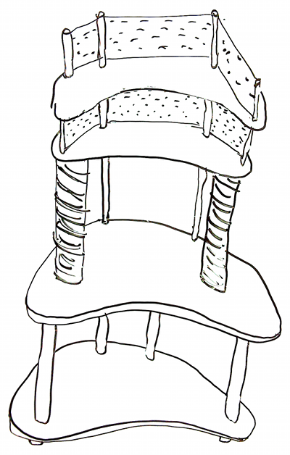 | Is it…  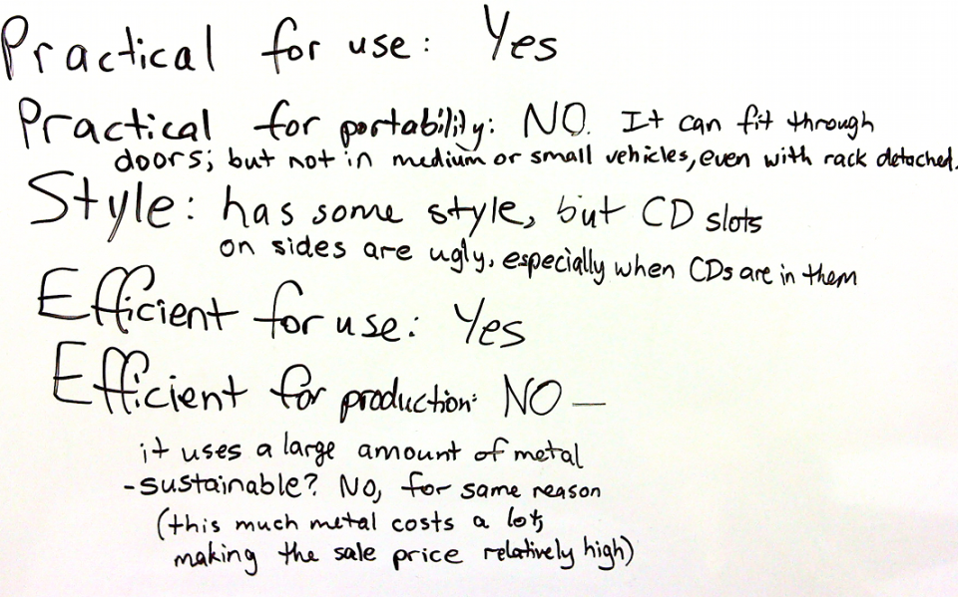
- Disc Racks (slotted parts) look ugly especially so once you put any discs in them.
- Panel near floor gets in the way of your feet and small items are lost under it easily (and the panel is required for structural integrity in this design, unless steel arches were added between the pillars which would use more metal)

Solid Wood Model
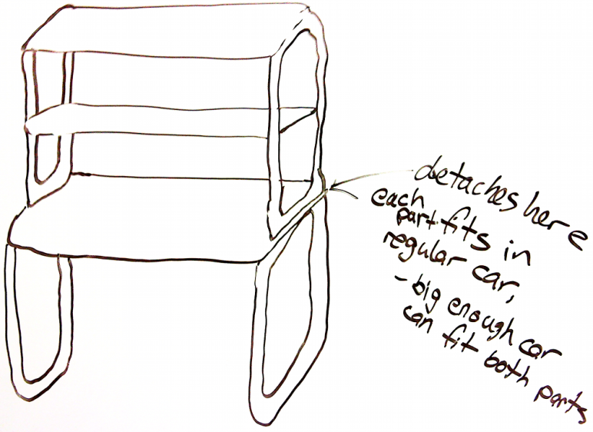
- It is solid wood, so it looks uniform
- Elegant design even though uses only wood (rectangles are actually 4 pieces, but they are cut and rounded in order to accommodate the design)
- It is just as solid as the Fiberboard and Steel design, even without a panel near floor.

