Using Blender 2.7 - Topics - Rigid Body Constraints (hinge)

Create a seesaw and make a bar that functions as a hinge
- Create a plank that is sitting on a bar (like a seesaw)
- Create an object that will fall onto the plank
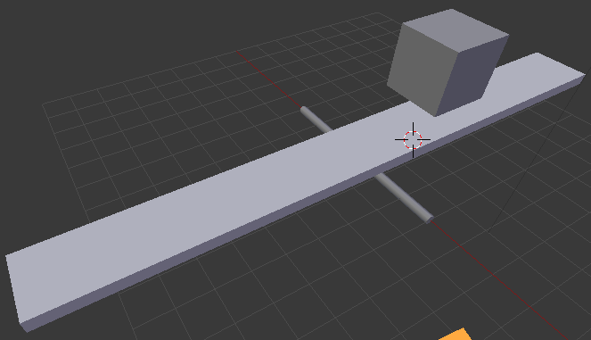
Add the physics settings:
- Go to Physics tab on left
- Select the object that will fall onto the plank
- Click "Add Active" in Physics tab
- Select the plank
- Click "Add Active" in Physics tab
- Select the bar
- Click "Add Passive" in Physics tab (this makes it stay still but affect other objects)
- With the bar selected first, shift-click to select the plank so it is active (light green outline) but bar is still selected (dark green outline)
- Click "Connect" in physics tab
- Change type to "Hinge"

Change the axis of rotation (the z axis must be pointing the same way as the bar):
- Press z to change the viewport shading to Wireframe.
- If you look closely, you can see there is a new set of axes that are all green. That is the rigid body constraint.
- Select the rigid body constraint object so it is highlighted in light green:
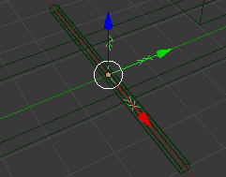
- Rotate that constraint so that the z axis is pointing the same way as the bar (such as by pressing r then y then typing 90 then enter, if yours is oriented like the example above)

