Using Blender 2.6 for Animation - Blender Caveats (Ways You Might Get Stuck When Animating)
Solutions tested on Blender 2.6 or above

ISSUE: rotation wobbles once in the middle (the object refuses to restrict animation to one axis)
SOLUTION:, delete the bad keyframes, then change "Delta Transform" value in the Object Button tab (instead of using rotation tool), then right-click that value and click "Insert Keyframe". Here are instructions on how to do that:
Delete the bad keyframes:
- Click "3D View" and change it to a "Dopesheet"
- Delete bad keyframes for the object (right-click each rotation [x, y, and z] separately and then press the Delete key)
Now Set the objects starting rotation:
- Make sure Automatic keyframe mode is OFF: (the red circle button is this light color when off)
- Rotate the object to its starting position
Insert Delta Rotation keyframes:
- Go to the frame where the object should start moving (the last frame where it stays still is the first frame of the animation)
- Click the Object button
- Under "Delta Transform" (click to expand it if you do not see "Delta Location", "Rotation", & "Delta Scale" columns), find the axis you want to rotate under "Rotate", then right-click that box, and click "Insert Keyframes"
- Go to the next frame in the animation (the end of the motion)
- To rotate the object, only use the "Rotation" box under "Delta Rotation" (instead of rotating the object with the mouse, drag the value left or right or type in a value)
- Right-click the box for the axis where you changed a rotation value, then click "Insert Keyframes"
Now the object should only rotate on one axis.
If "Replace Keyframe" doesn't have any effect, try deleting the keyframe for that property using the "Dopesheet" view

ISSUE: Fluid looks like a non-moving box (does not animate even though bake files exist):
- Select the fluid domain
- Under the Physics button tab, at the bottom of the Fluid category (above Domain World category), click browse button
- Click the folder where the bake files are stored (bvel.gz and bobj.gz files)
- Make sure the second box is empty:
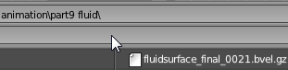
- Click Accept
- If it still fails, try restarting the program & retrying these steps. If it stil fails, re-bake.

ISSUE: “Cannot Initialize Audio” error upon attempting to Render Animation with audio
SOLUTION:
- Click Scene button tab
  - Click “update animation cache” then wait for it to finish (When it is finished, you’ll be able to click)
  - Under “Audio” category, click the drop-down box under Format and choose “Stereo”
- Click the Render button tab
  - Under the “Output” category choose MPEG and for filename type in a name followed by
.mpg (e.g. myanim.mpg)
  - Under the “Encoding” category choose DVD from the main drop-down box (Presets)

ISSUE: Animated objects don’t move in Blender Game engine
SOLUTION:
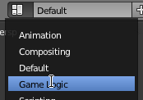
- You need to program them, not animate them.
- For screen layout, change from Default to Game Logic

- Add Sensor, Keyboard

- Click the blank box by “key” and then press the Ctrl key

- Add Controller, “And”

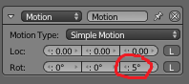
- Add Actuator, Motion. Change the values for how much you want the keypress to affect the object (example shows z rotation of 5 degrees):

Drag to draw lines to connect the sensor to the controller:
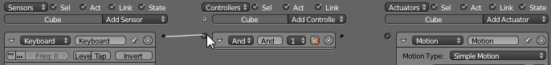
And controller to actuator:

