Using Blender 2.6 for Animation - Part 0.1 - Introduction to Blender 2.6: Instructions and Blend Files
GOAL: Learn how to navigate the course materials and Blender.

How these lessons are written and organized:
- GOALS are at the top of each part.
- Numbering: Part 1.1 is Part 1, page 1
- The assignment/project requirements are at the bottom of the last page (such as 0.2) of each part. Pages are normally printed front and back.
- If you are in any computer classes in High School using these directions, you should have two drives:
  - Drive H: (name is same as your login) – this is where you save assignments (making a folder for each class may be helpful)
  - Drive S: (named StudentSharedFiles) – this is where the teacher saves these directions & example files for some projects
- If you are a student, these instructions should always be in Start, Computer, StudentSharedFiles then the name of your class. For information on a certain topic, you can look at the filename for each part, and look up optional topics in the “Topics” folder.
- The line above a bulleted list tells what the following list does. If you want to know how to do something, look at the line above a bulleted list (for example, since the line above this bulleted list is “How these lessons are organized” you know all of these bullets will help you with that).
- Tips are italicized or in boxes are optional, but can help you if you are stuck. Also if stuck, reread instructions.
- If you are in any of Mr. Gustafson’s classes in school, please go to Start, Computer, StudentSharedFiles, and read “FCA Students in All of Mr. Gustafson’s Computer Classes - Read This for Grading and Expectations”

How to read instructions involving pushing keys at once or in a row:
- Click means left click. Only right-click means right-click.
- Shift Right-Click would mean hold the shift key on the keyboard, right-click, then let go of shift.
- Ctrl G would mean hold the Ctrl key on the keyboard, press G once, then let go of Ctrl too.
- Press s, z would mean press the ‘s’ key on the keyboard once, let go, then press the ‘z’ key once & let go (this example is for shortcut keys pressed in a row to scale the object on the z axis).

Blender is a free program that is often used in independent movies & foreign movies for special effects. It was originally created by the Dutch game company NeoGeo, but later it was purchased by the community and is now Free-Libre Open Source Software so you can download it and modify it according to the GNU General Public License. (“History”) You can go to blender.org at home to legally download it for free.
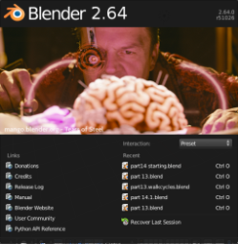
When Blender first opens, it shows the splash screen for your version. This type of screen in any program is called the splash screen (see 2.64 splash screen on left).
--You can click the picture to continue, or click a previous file from the list under it if someone has used the program on your computer before with your username.

Saving Files:
- Blend files are your 3D project files for Blender. Only people with Blender can open these. You can also make pictures & video files that anyone can see using Blender or another 3D program. Making a 2D picture or video from a 3D scene is called Rendering.
- To name the file, click File, Save As
- In the list of the left choose H:
- In the second box type a name for the file.
- After clicking H: you can Create New Directory and name it for your class if you want.
- H: is your home drive. All work should be saved there—this is how you hand in your work. Also, no matter what computer you use on your school’s network, you can see your files in your H: drive as long as you are logged in.
- Blender does not save or ask to save when it exits, so you must always click File, Save before you exit/logout.
- If you did not save before closing, you will have to open Blender again & try to find a recent Autosave: click “File”, “Recover Last Session” or “File”, “Recover Auto Save…”, then after you have found the file that you want to keep, you must click File, Save As, & follow the instructions above to save in H: & name it in the second box.
(continue to next page)
Using Blender 2.6 for Animation - Part 0.2 - Introduction to Blender 2.6: The Blender Interface

The Blender interface:
- The default layout has 5 editors: an Info bar (just a menu bar and layout options), a 3D View (where you edit the 3D scene directly), a Timeline editor (where you control and edit the animation), an Outliner (showing all objects by name), and a Properties editor (where you adjust properties [attributes] of the scene and objects):
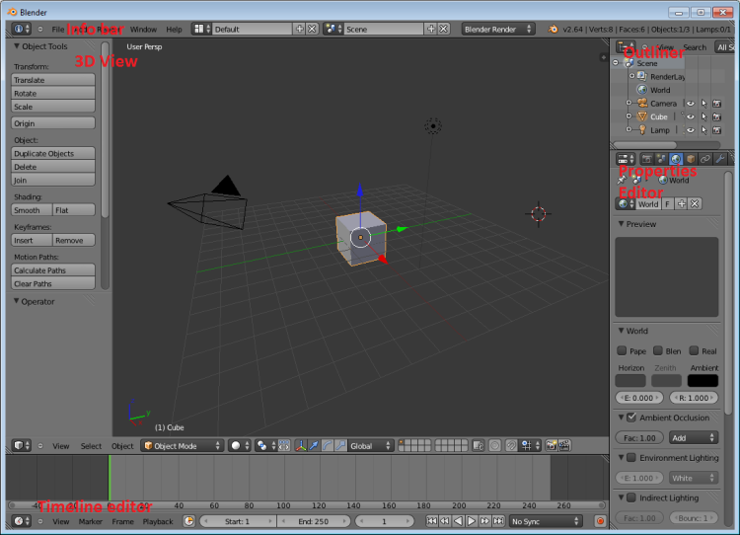
--you can drag the black lines to change the size of any editor.
(If if you shrink a shelf of a view, the shelf will disappear, & you can click the plus sign box to get it back: )
- The default scene has 3 objects: a camera 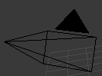, light , and cube mesh 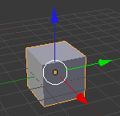 to get you started.
- You can add more meshes by clicking Add, Mesh, than any type of mesh.
- You can also download objects provided by the teacher, save them to your home drive H:, then import them (File, Import, choose name of program, click S:\Public\Meshes, then choose the file)
- You can click & drag the arrows to move the object in a certain direction.
- You can right-click to select a different object (or left-click it in the Outliner)
- You can change mode using the mode drop-down box to work with objects, edit selected object, or other things:
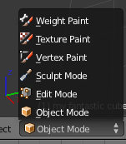
- In Object Mode, on the Properties editor on right, in the Object Button tab,
you can rename objects (click the light gray box, type a name, press enter):
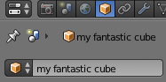

Part 0 Practice
- Rename an object using the step above
- File, Save As, on left click H: as always, in second box name the file Part 0 Naming (to confirm press enter twice)!
- Remember, to save changes you made since last save, before you exit you must click File, Save—it won’t ask before exit!

